**Elastic Beanstalk**

**Step-1:** Create a new application by clicking on

“Create New Application”

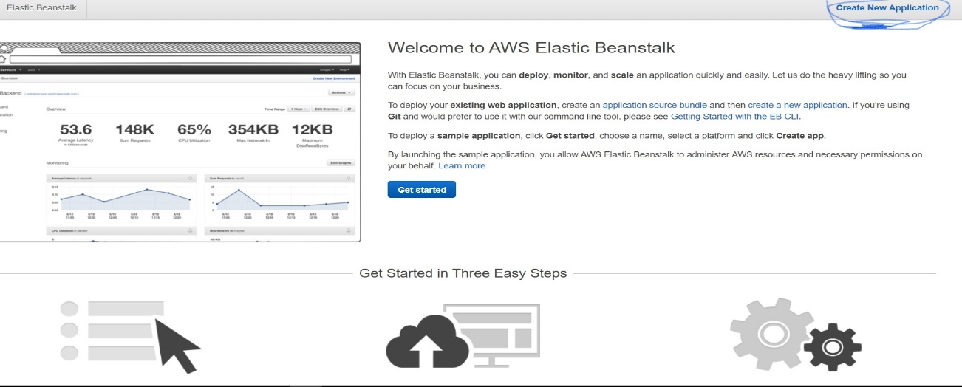

Step-2: Write application name and description of application.

Application Name: give application name

Description: give information of application.

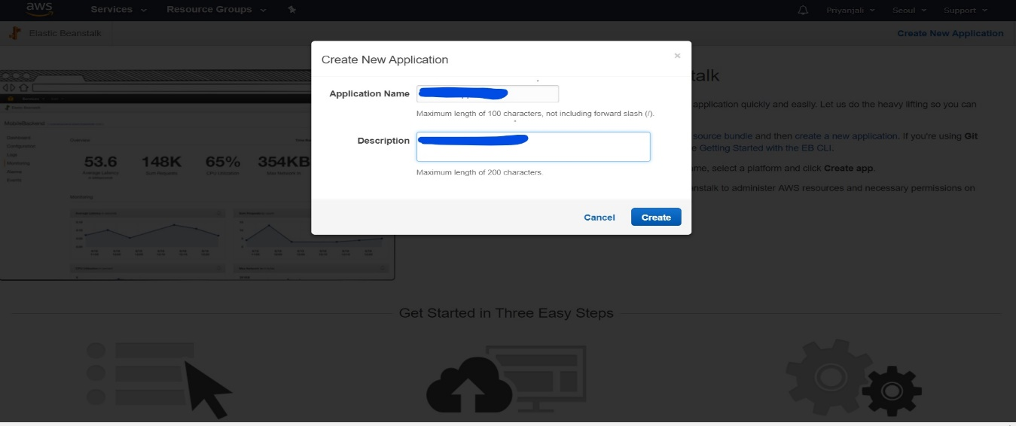

Step-3: Create new environment by clicking on

“Create one now”

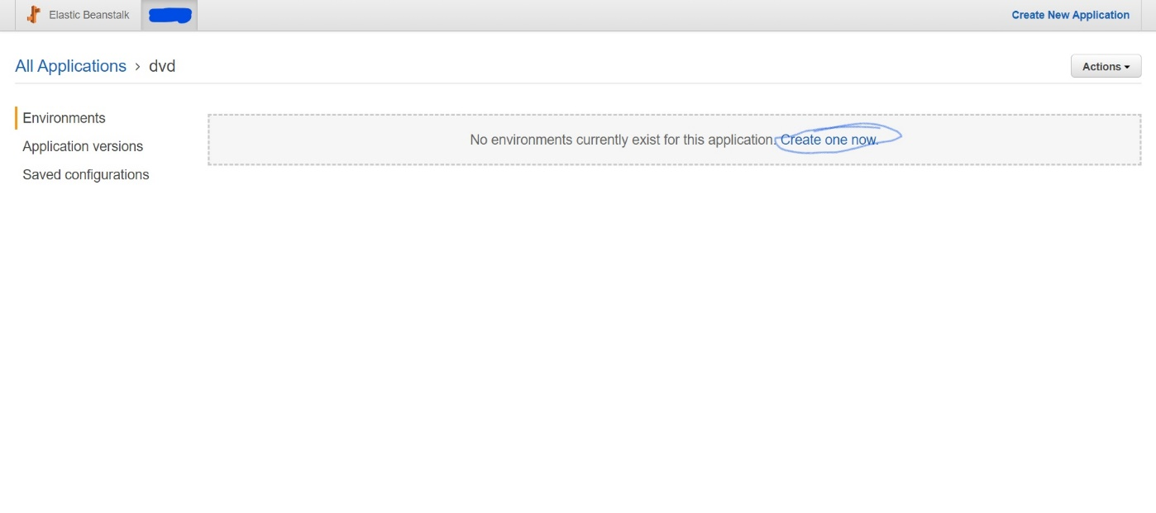

Step-4: Now select environment as per requirement, click on “Web server environment” and then click on “select”

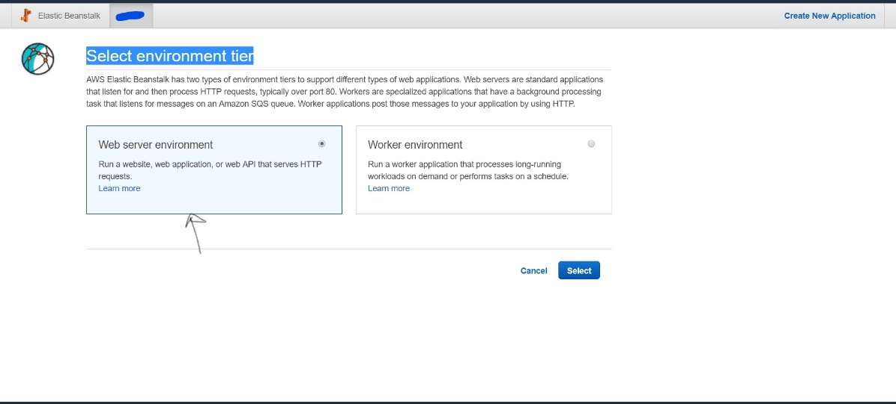

Step-5: You are in “Create a Web server environment” Put domain name which you want in URL, in platform choose server “tomcat” as per requirement.

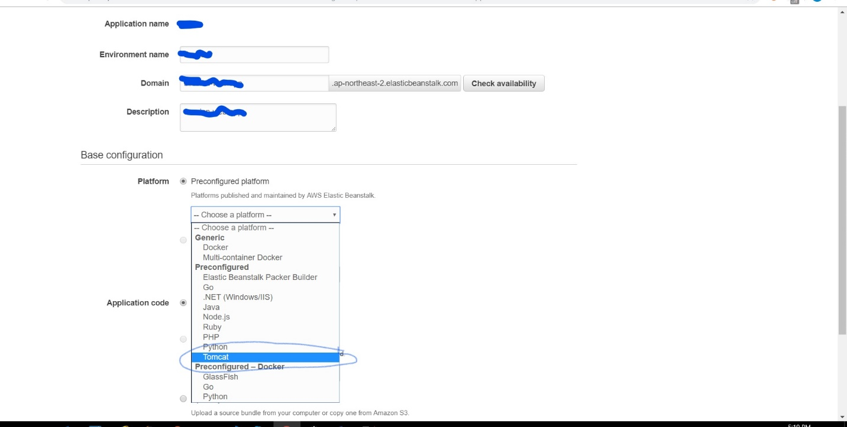

Step-6: In application code, click on “Upload your code” then click on “Upload” button.

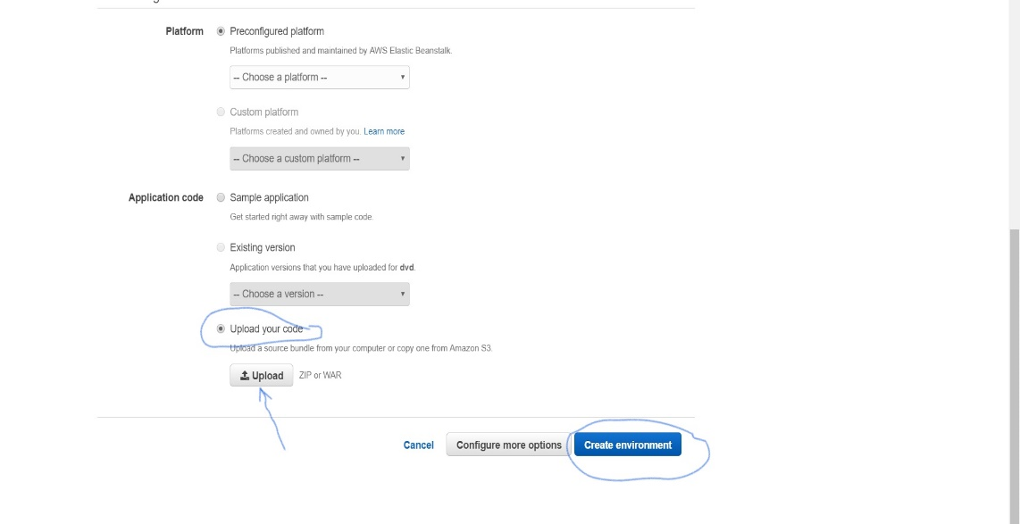

Step-7: Now click on “Public s3 URL” and give s3 URL where you have kept your project’s WAR file.(You need to create one s3 and put war file on that s3 and copy URL)

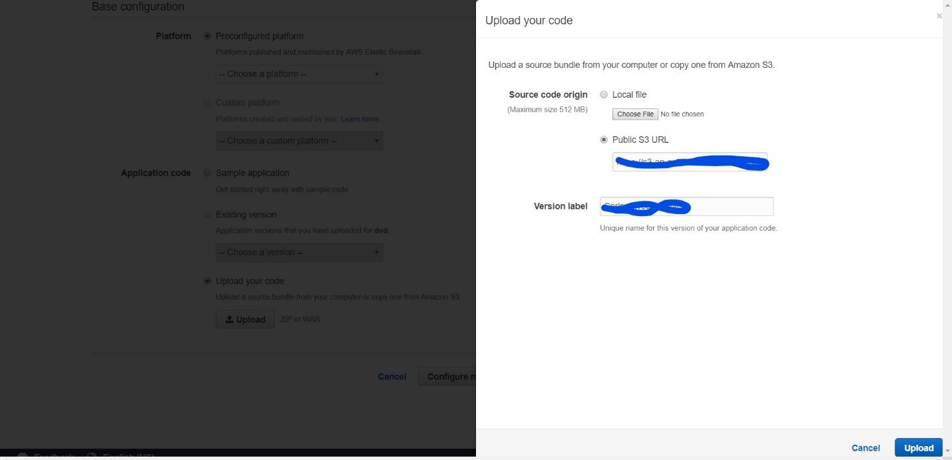

Step-8: Now click on “Upload” and then click on “create environment”.